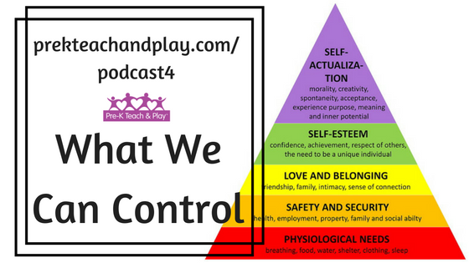
Directions: Individually, or with other team members, identify a single presenting issue or make a list of policies or practices you feel should stop, start, or be changed in some way. Then, for each issue or concern, determine if you and/or your team members have the ability to control the situation, influence, or move to a place of acceptance. This process will help you and your team, determine where to put their limited time, energy, and resources.
Control  When can you/your team  have the final say regarding an outcome?  When can you/your team make the final decision?  What can you/your team change without seeking permission or approval from others? | Influence  When can you/your team  have a say or a vote in the outcome?  When can you/your team  influence the final decision?  What can you/your team influence through advocacy and/or by educating others? | Accept  When can’t you/your team have a say in the outcome?  When can’t you/your team impact the final decision (e.g., the decision has been made)?  What can’t you/your team do because others are not listening or willing to change?

©2016 Kristie Pretti-Frontczak. All rights reserved. http://kristiepf.com

